Table of Contents

1.0. Introduction 1

2.0. Stages of Growth and Development 1

2.1. Infancy (0–1 year) 1

2.2. Childhood (2–12 years) 3

2.3. Adolescence (12–18 years) 3

2.4. Early to Late Adulthood (20+ years) 5

2.5. Developmental Norms and Milestones 6

3.0. Effects of Life Factors and Events on Growth and Development 7

3.1. Life Factors and Events 7

3.2. Impact of These Factors on Development 8

3.2.1. Genetic Influences: 8

3.2.2. Socioeconomic Status: 8

3.2.3. Major Life Events: 8

4.0. Physical and Psychological Changes of Ageing 9

4.1. Physical Changes of Ageing: Musculoskeletal and Respiratory Systems 9

4.2. Psychological Changes 10

4.3. Impact of Physical Changes on Self-Esteem and Lifestyle Choices 10

5.0. Transitions and Significant Life Events 11

5.1. Identification and Description of Transitions 11

5.2. Impact of These Transitions 11

5.3. Role of Health and Social Care Practitioners 12

References 14

# Introduction

The developmental journey of human beings expands throughout their entire life through different phases that exhibit specific developmental markers and obstacles. Each stage in human life brings essential transitions that form present capabilities and establish base frameworks for upcoming development. Human development maintains a state of constant change because it depends on multiple complex interactions between genes and environmental conditions and social culture contexts, which creates an extensive and multi-dimensional research field.

Developmental psychology establishes an organized framework that helps researchers understand human growth by studying developmental processes in life. This report analyses development through infancy, childhood, adolescence, adulthood, and late adulthood to understand the individual growth of physical, emotional, cognitive, and social aspects. The exploration of early experiences reveals their power to shape future results, while essential events in development stages strongly affect personal life paths. The detailed analysis demonstrates why development monitoring during different life phases remains essential for obtaining optimal results that promote well-being through supportive interventions.

# 2.0. Stages of Growth and Development

## 2.1. Infancy (0–1 year)

The growth path during infancy becomes incredibly fast because infants experience substantial increases in weight and height (Morioka et al., 2025). Orenstein and Lewis (2022) explained that by five months old, infants achieve their birth weight double and reach triple their birth weight before their first birthday arrives. Children become capable of controlled physical activities while developing their motor skills during their first year of growth (Campbell, 2021). The development of motor skills receives its essential formation during this stage because early motor experiences and appropriate nutrition strongly impact future physical activity and health outcomes(Morioka et al., 2025).

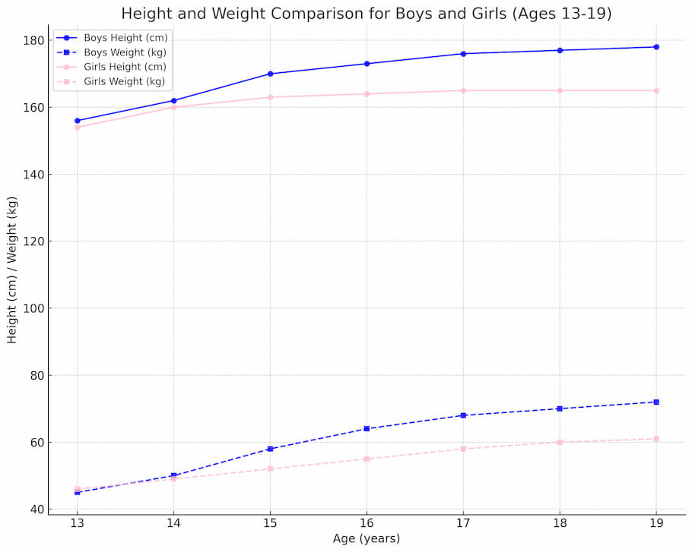

Figure 2.1: Height-to-Weight Ratio Chart for Infants to Teens

According to Ulijaszek et al. (2025), infants' neurological systems develop rapidly to generate cognitive abilities that begin with sensory processing and end with symbolic thought capabilities. For Burri (2024), sensorimotor development spans when infants learn from environmental contact until they reach object permanence status. Children primarily understand their environment through direct exploration, leading them to generate advanced mental representations.

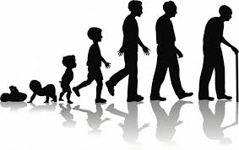

Figure 2.2: Visual timeline showing key motor development milestones such as rolling over, sitting up, crawling, and walking.

The initial twelve months of life are essential for emotional growth since they create fundamental relationships that shape future social bonds (Burri, 2024). Developing secure attachments through sensitive caregiving produces better emotional control and enhanced social abilities (Mumford, 2021). Basic emotional processes and social interaction abilities emerge when infants produce smiling behaviours because of their encounters with parents, demonstrating how social development depends on emotional growth (Campbell, 2021).

## 2.2. Childhood (2–12 years)

Childhood involves continuous height and weight growth while children learn essential gross and fine motor abilities (Oesterdiekhoff, 2021). Students can improve their physical confidence and coordination through playing activities, drawing, and school-based physical education. These activities help develop essential skills. Active physical activity is more likely during this stage because the refinement of motor skills leads to better physical development (Eze et al., 2021).

Furthermore, cognitive abilities develop substantially as children advance from concrete operational stages to solve complex problems (Ulijaszek et al., 2025). School education is important during this stage because it moulds students' thinking abilities, reasoning capabilities, and knowledge retention (Ulijaszek et al., 2025). The ability to handle information, learn abstract ideas, and boost memory performance and attention capacity develops in children (Orenstein & Lewis, 2022).

As per Mumford's (2021) research, social skills progress toward advanced levels when children establish friends and develop peer connections. Children advance in emotional maturity through their improved ability to understand, express, and control emotions (Bogin, 2020). Children develop social-emotional capacity through their school environment because they learn conflict resolution skills and social interaction techniques with different people (Morioka et al., 2025).

## 2.3. Adolescence (12–18 years)

Hormonal changes during puberty transform adolescents into entirely new beings with their physical attributes (Loid et al., 2024). Huang (2024) posited that adolescents experience fast physical growth and the emergence of secondary sex characteristics while their bodies rapidly gain height and weight. Motor skills attain full development through notable improvements in strength, agility, and coordination, frequently leading teenagers to participate in sports and other physical events (Cameron, 2024).

Adolescents develop higher-level reasoning skills, including abstract thinking and hypothetical and deductive reasoning (Cameron, 2024). During adolescence, young individuals examine moral questions, philosophical matters, political issues, and social problems, and their emotional connection to others becomes more profound (Eze et al., 2021). Additionally, the study of Orenstein and Lewis (2022) further concluded that developing advanced cognitive capacity enables adolescents to understand complex ideas better and use their acquired knowledge in real-world applications.

During adolescence, individuals go through the vital development of their identity while simultaneously seeking independence (Beckett & Taylor, 2024). During this developmental phase, the most significant relationships stem from peer associations. The emotional development of adolescents includes heightened emotional awareness and more profound emotional experiences alongside hormonal fluctuations that may produce more conflicts and unstable moods (Pérez-Cano et al., 2024).

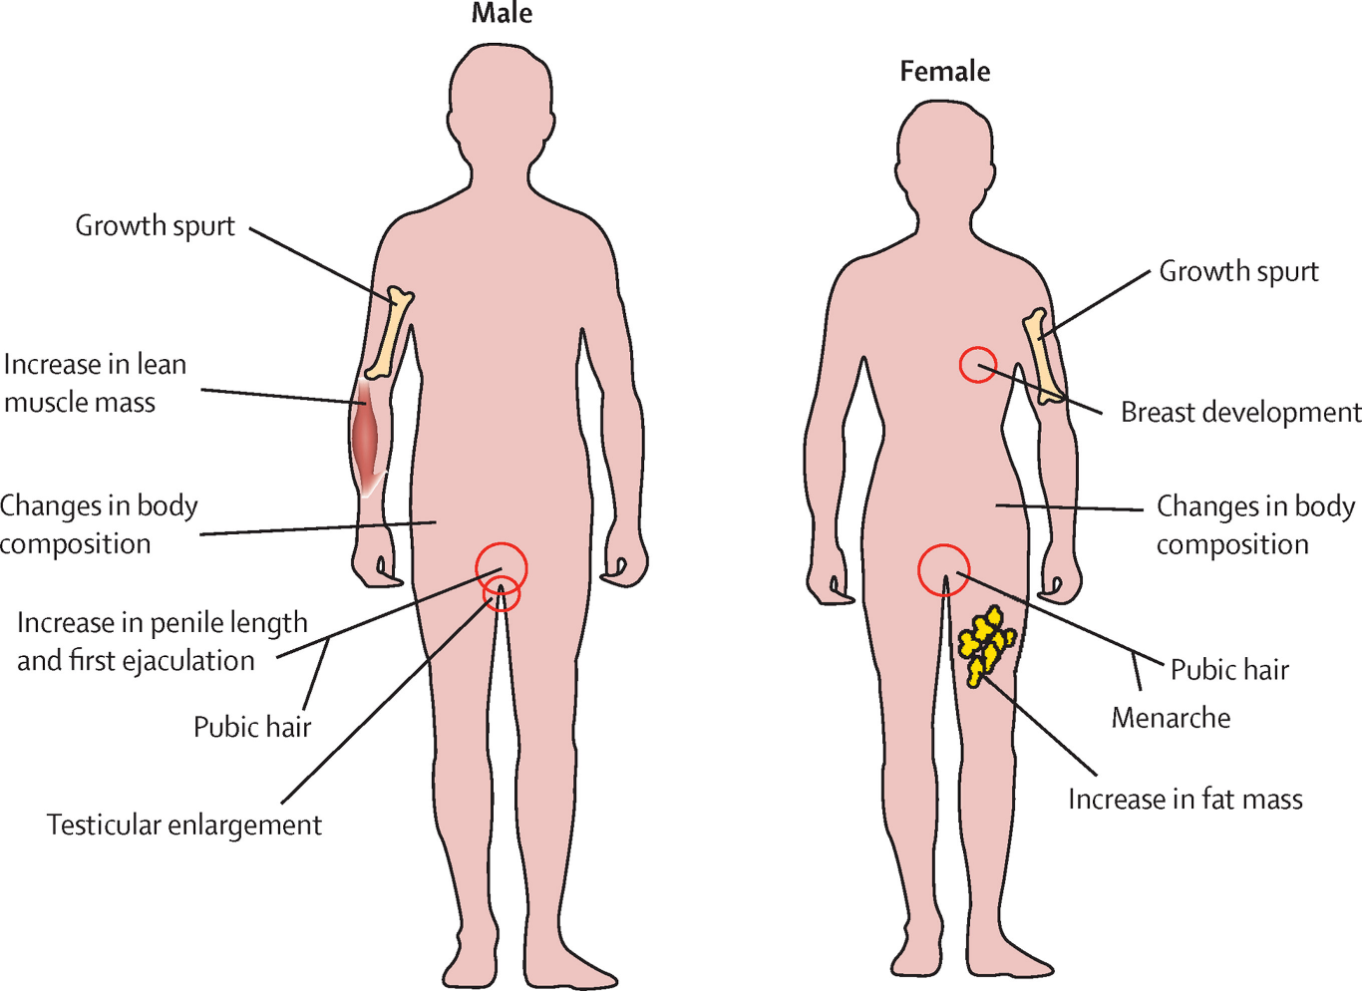

Figure 2.3: Major pubertal changes, including secondary sexual characteristics and their typical age of onset

## 2.4. Early to Late Adulthood (20+ years)

During early adulthood, people typically reach maximum physical wellness while experiencing their strongest muscles. According to Loid et al. (2024), physical capabilities show signs of deterioration throughout the aging process, starting from middle age to late adulthood, because muscle decreases, bones weaken, and strength levels drop. The changes emphasize how regular physical activity helps fight against growing older-related physical deterioration (Ren et al., 2025). Adult mental growth includes growing mastery with more profound understanding, but processing speed decreases after middle age (Trigueros et al., 2025). Adults maintain learning abilities as they use their experience along with gained knowledge to tackle problems while making decisions. Learning throughout life is essential for maintaining and developing cognitive functions throughout adulthood (Morioka et al., 2025).

Bogin (2020) explained that adults' emotional experiences become more defined as emotional regulation improves and individuals place more emphasis on significant relationships. Adults undergo substantial social role transformations, from family formation to career development, and eventually retire (Pérez-Cano et al., 2024). The different life stages introduce social identity transformations and emotional welfare modifications.

## 2.5. Developmental Norms and Milestones

Understanding developmental norms and milestones is crucial for monitoring the progression of physical, intellectual, and emotional/social development throughout various life stages. These milestones serve as benchmarks that guide expectations for typical development and help in identifying potential developmental delays or disorders. For example, in infancy, expected milestones include behaviours such as smiling for the first time, babbling, and eventually speaking a first word. As children reach preschool age, professionals look for more sophisticated motor skills like hopping on one foot, drawing shapes, and forming complex sentences. Such milestones are significant indicators of neurodevelopmental health and cognitive processing abilities (Loid et al., 2024).

As developmental stages progress, the complexity of these milestones increases, reflecting the intricate interplay between physical, intellectual, and emotional/social growth. For instance, during adolescence, milestones not only encompass physical changes such as puberty but also include cognitive milestones like the development of abstract thinking, as well as emotional and social milestones such as establishing an identity and achieving emotional independence from parents. These transitions are pivotal, as they lay the groundwork for adult social interactions and emotional well-being. Intellectual achievements in this stage are particularly crucial, as they set the stage for academic and occupational successes in later life (Huang, 2024).

To provide a deeper context, it's important to consider how early developmental experiences can influence later outcomes. Early physical health, for instance, can affect educational performance; a child with chronic physical health issues may miss more school and thus have fewer academic achievements. Similarly, early cognitive abilities, such as language acquisition and problem-solving skills, are foundational for later complex learning tasks and social negotiations in the school environment (Burri, 2024). Furthermore, emotional and social development in early childhood, such as the ability to manage frustrations and interact cooperatively with peers, is predictive of future relational skills and emotional resilience. These interconnected aspects underscore the holistic nature of human development, where advancements in one area often enhance or limit progress in others.

Understanding and monitoring these milestones allow for timely interventions that can significantly alter a child's developmental trajectory. Interventions might include targeted educational programs, speech therapy, or social skills groups, depending on the area of delay. By recognizing and addressing these developmental markers early, professionals can support children in achieving their full potential across all domains of development, illustrating the critical role of comprehensive developmental assessments in fostering optimal growth and well-being.

# 3.0. Effects of Life Factors and Events on Growth and Development

## 3.1. Life Factors and Events

Human development depends significantly on mutual interactions among genetic inheritance, genetics, and socioeconomic status (SES), together with major life events. All biological traits, including appearance attributes and disease risk factors, together with cognitive abilities, exist through DNA-encoded genetic inheritance. Procopio et al. (2025) argue that genetic inheritance establishes maximum developmental limits that environmental elements ultimately determine through their interactions. Socioeconomic status operates as a fundamental resource pathway that affects developmental outcomes through its elements of income, education, and occupation (Bradley & Corwyn, 2021). The life path of individuals becomes disrupted through major life events, including traumatic occurrences and critical transitions such as parental divorce and severe illnesses, according to Masten (2023).

## 3.2. Impact of These Factors on Development

### 3.2.1. Genetic Influences:

Development begins with genetic influences, which determine the natural boundaries for physical and psychological traits that can be expressed by individuals. According to Silventoinen et al. (2020), certain diseases with genetic predispositions affect both the physical development and early-life health of people. Intellectual capacities receive genetic influence together with Down syndrome, which stems from chromosomal anomalies leading to distinct educational requirements (Hagerman et al., 2021). Genetic background determines how people behave emotionally by affecting mental impulses that could limit emotional control abilities (Caldani et al., 2020). The genetic basis leads to autism spectrum disorder, among other disorders, which create social interaction challenges for individuals (Chen & Geschwind, 2022).

### 3.2.2. Socioeconomic Status:

Socioeconomic status influences developmental outcomes through access to nutrition, healthcare, educational opportunities, and stable living conditions. Children from lower socioeconomic backgrounds develop more developmental delays along with chronic health issues because they cannot access proper nutritious food or healthcare services (Duncan et al., 2021). The mismatch of educational resources between wealthy and disadvantaged families produces major gaps between the academic achievements and mental development of children (Levine et al., 2020). Persistent stress from poverty leads to the development of long-lasting psychological conditions that produce depression and anxiety (Evans & Kim, 2021). Social differences caused by SES create problems regarding interaction quality between people which reduces both physical movement possibilities and social networking potential (Lareau et al., 2023).

### 3.2.3. Major Life Events:

Life events of significant magnitude serve simultaneously as development enhancers and obstacles against typical developmental progression. Physical experiences, including long-term diseases or wounds, frequently modify bodily processes as well as the natural patterns of physical development (Hamai & Felitti, 2021). The intellectual development of children is affected by migration, together with family disturbances that disrupt educational progression and cognitive growth (Betancourt et al., 2024). The death of someone close to them, along with parental breakdown, creates intense emotional suffering that shapes how a child matures emotionally (Amato et al., 2021). The social development of children receives a positive or negative impact through their participation in community events or exposure to social isolation situations (Werner et al., 2021).

# 4.0. Physical and Psychological Changes of Ageing

## 4.1. Physical Changes of Ageing: Musculoskeletal and Respiratory Systems

Old age triggers substantial alterations throughout the musculoskeletal system as well as the respiratory system while affecting both structure and functionality (Beckett & Taylor, 2024). Amato et al. (2021) explained that sarcopenia affects the musculoskeletal system of elderly patients by causing muscle mass reduction and strength and bone density decline, which results in poor mobility while raising fracture danger. Postmenopausal women most commonly develop bone density decline because of osteoporosis, causing them to become more susceptible to fractures from simple falls (Seydakova, 2024). Osteoarthritis develops due to joint cartilage degeneration, thus causing movement restrictions and pain that impact daily routines and decrease life quality (Werner et al., 2021).

The aging process causes noticeable deterioration within the respiratory system. The aging respiratory function experiences three main changes, which lead to decreased lung compliance while reducing vital capacity and diffusion capacity to lower oxygen exchange efficiency (Braun & Hill, 2025b). The combined effects of structural changes in a thoracic cage and lung parenchyma worsen functional decline that reduces breathing efficiency because respiratory muscles weaken (Cai et al., 2025). In the study of Seydakova (2024), older individuals face challenges with their respiratory tract functioning in responding to hypoxia and hypercapnia, which impacts the management of COPD among smokers.

## 4.2. Psychological Changes

When people grow older, their cognitive ability shows specific patterns of reduction, including processing speed, which slows down and diminishes executive capabilities for multitasking and problem-solving (Gunes et al., 2025). Crystallized intelligence demonstrates stable or improved performance over time as people accumulate knowledge and experience, thereby helping them maintain other cognitive functions (Caldani et al., 2020). The impact of cognitive function on self-esteem demonstrates intricate patterns even while cognitive aging takes place. self-esteem does not suffer directly from cognitive decline, yet it responds to changes in social roles and social functioning (Evans & Kim, 2021). This means that Cognitive deterioration fails to reduce self-esteem in elderly adults because positive social experiences and appreciation for family dynamics show strong correlations to increased self-esteem.

## 4.3. Impact of Physical Changes on Self-Esteem and Lifestyle Choices

Self-esteem decreases in older individuals because of physical and cognitive aging changes, resulting in deteriorated abilities that may produce diminished self-perception and a weakened quality of life (Hagerman et al., 2024). The proper selection of lifestyle behaviours can offset the negative impact of ageing on self-esteem. Per Procopio et al. (2025) research, the combination of exercise activities along with social interaction patterns both enhance physical self-awareness and raise overall self-perception. Serious mental activity involving reading as well as puzzles helps protect cognitive abilities and self-esteem while proving the essential relationship between health and mental wellness in older people (Williams, 2025).

# 5.0. Transitions and Significant Life Events

## 5.1. Identification and Description of Transitions

Human life features three fundamental transition stages that include starting education and job changes and ending work to retire which represent important developmental phases with major psychosocial and economic impacts (Stambulova et al., 2020). When children start kindergarten, they join structured education environments, which start their academic development process while setting important stages for social growth (Inoue et al., 2025). Adult transitions redefine both personal identity and financial independence because they involve movements across different career levels, including new job beginnings and advancements, along with the risk of unemployment (Roux et al., 2022). The major life alteration of retirement takes place in late adulthood when people leave the workforce to face a fundamental transformation of routine activities and personal identity (Lambert, 2025). These transitions affect an individual's present circumstances at the same time they shape upcoming possibilities and obstacles throughout the life span because of development's fluid quality across the life course.

## 5.2. Impact of These Transitions

The transitions identified profoundly affect emotional well-being, financial stability, and social relationships. Entering education can trigger a mix of excitement and anxiety in children, influencing their long-term academic and social outcomes; successful adaptation may enhance self-esteem and academic performance, whereas struggles can lead to detrimental effects on self-worth (Ladd, 2022). Employment changes often bring about stress and uncertainty, particularly during periods of job loss, which are associated with increased risks of depression and anxiety; conversely, career advancements or fulfilling work can significantly boost life satisfaction and self-esteem (Roux et al., 2022). Retirement brings its own set of challenges and adjustments: while it may reduce daily stress and offer more free time, it can also lead to a loss of identity and social isolation if the transition is not managed well, mainly if retirement is involuntary (Betancourt et al., 2024). These transitions necessitate considerable adjustments in personal and social identities, impacting individuals' well-being across various dimensions.

## 5.3. Role of Health and Social Care Practitioners

Health and social care practitioners deliver essential support to individuals who encounter these critical life changes. The critical support structures in which professionals in education roles, counsellors, career advisors, and geriatric specialists provide imperative direction to people during these life stage alterations (Lei et al., 2025). School counselors help students transition smoothly to educational settings, yet career advisors provide clients with counseling services and skill development training (Lambert, 2025). The staff of gerontologists and social workers delivers resources and support to assist seniors in their adaptation process as they navigate retirement life through active aging principles (Abril et al., 2025).

Managing life transitions through person-centered approaches gives maximum respect to individual needs, preferences, and personal values (Gunes et al., 2025). Williams (2025) described this approach as setting itself apart due to its ability to recognize essential transition elements while constructing support systems based on personal needs. The personalized approach makes people feel more empowered and assisted through critical changes, improving their adaptation and success (Gunes et al., 2025). In educational settings, person-centered approaches develop customized learning plans that incorporate specific student abilities, difficulties, and academic preferences. Implementing this method enhances educational transitions between schools, particularly when students move from primary to secondary education, which carries advanced academic responsibilities (Evans & Kim, 2021). Educational strategies focusing on individual learning requirements enable instructors to help students adapt to changes better, decreasing their anxiety while improving their academic outcomes.

Workplace person-centered methods apply as customized career development plans. The plans incorporate evaluations of a person's abilities and position needs, professional future directions, and social situation (Werner et al., 2021). A person transitioning jobs needs a plan that provides education about new competencies, mentoring programs, and adaptable work schedules to manage family duties (Lareau et al., 2023). A personalized approach to support enables transitional employees to profit by managing changes while sustaining or strengthening their job happiness and performance levels. The process of preparing for retirement requires person-centered approaches to deliver optimal results. A successful retirement plan needs more than financial preparation; it must also recognize the retiree's preferred lifestyle, health requirements, and social network needs. Retirement plans should include person-specific guidance about physical activity, access to social engagement, and mentally stimulating activities (Lambert, 2025). This comprehensive method allows people to transition from working life to retirement while improving their sense of meaning and wellness during their non-working years.

# References

Abril, L., Gilbert, L., Pacheco, F., Takematsu, M., Davitt, M., Schimmrich, K., Baer, J., Mazarin, G., Gupta, C., Adewunmi, V., Irizarry, E., & Friedman, B. W. (2025). A Prospective Cohort Study to Determine Which Opioid-Naïve Emergency Department Patients Are at Risk of Persistent Opioid Use. *Annals of Emergency Medicine*. https://doi.org/10.1016/j.annemergmed.2025.02.025

Amato, K. R., Arrieta, M.-C., Azad, M. B., Bailey, M. T., Broussard, J. L., Bruggeling, C. E., Claud, E. C., Costello, E. K., Davenport, E. R., Dutilh, B. E., Ewald, H. A. S., Ewald, P., Hanlon, E. C., Julion, W., Keshavarzian, A., Maurice, C. F., Miller, G. E., Preidis, G. A., Segurel, L., & Singer, B. (2021). The human gut microbiome and health inequities. *Proceedings of the National Academy of Sciences*, *118*(25). https://doi.org/10.1073/pnas.2017947118

Beckett, C., & Taylor, H. (2024). Human Growth and Development. *Www.torrossa.com*, 1–100. https://www.torrossa.com/gs/resourceProxy?an=5730604&publisher=FZ7200

Betancourt, A. J., Wei, K. H.-C. ., Huang, Y., & Lee, Y. C. G. (2024). Causes and Consequences of Varying Transposable Element Activity: An Evolutionary Perspective. *Annual Review of Genomics and Human Genetics*, *25*(1), 1–25. https://doi.org/10.1146/annurev-genom-120822-105708

Bogin, B. (2020). *Patterns of Human Growth*. Google Books. https://books.google.com/books?hl=en&lr=&id=GPwAEAAAQBAJ&oi=fnd&pg=PR13&dq=Stages+of+Human+growth+and+Development&ots=5Ef-ETE0aZ&sig=liIB7oofrvDOdsqNBw9d5l2VXEM

Bradley, R. H., & Corwyn, R. F. (2021). Security and closeness with mothers and fathers in the transition to adolescence: Differences by temperament. *Journal of Family Psychology*, *35*(7), 950.

Braun, A. P., & Hill, M. A. (2025a). Even breathing gets old: Impact of ageing on small arteries of the diaphragm. *The Journal of Physiology*. https://doi.org/10.1113/jp288718

Braun, A. P., & Hill, M. A. (2025b). Even breathing gets old: Impact of ageing on small arteries of the diaphragm. *The Journal of Physiology*.

Burri, P. H. (2024). Structural Aspects of Prenatal and Postnatal Development and Growth of the Lung. *Lung Growth and Development*, 1–36. https://doi.org/10.1201/9781003574026-1

Cai, R., Huang, J., Chen, C., Ye, Z., & Cheng, B. (2025). Efficacy and Safety of Dupilumab in the Treatment of Refractory Atopic Dermatitis in Older Adults: A Retrospective, Single-Center Study. *Drugs & Aging*. https://doi.org/10.1007/s40266-025-01193-6

Caldani, S., Isel, F., Septier, M., Acquaviva, E., Delorme, R., & Bucci, M. P. (2020). Impairment in Attention Focus During the Posner Cognitive Task in Children With ADHD: An Eye Tracker Study. *Frontiers in Pediatrics*, *8*. https://doi.org/10.3389/fped.2020.00484

Cameron, N. (2024). Life history research and human biology. *Annals of Human Biology*, *51*(1). https://doi.org/10.1080/03014460.2024.2428057

Campbell, B. (2021). Stages of Development. *Springer EBooks*, 7905–7911. https://doi.org/10.1007/978-3-319-19650-3_762

Chen, G. T., & Geschwind, D. H. (2022). Challenges and opportunities for precision medicine in neurodevelopmental disorders. *Advanced Drug Delivery Reviews*, *191*, 114564. https://doi.org/10.1016/j.addr.2022.114564

Duncan, P. W., Bushnell, C., Sissine, M., Coleman, S., Lutz, B. J., Johnson, A. M., Radman, M., Pvru Bettger, J., Zorowitz, R. D., & Stein, J. (2021). Comprehensive Stroke Care and Outcomes. *Stroke*, *52*(1), 385–393. https://doi.org/10.1161/strokeaha.120.029678

Evans, G. W., & Kim, P. (2021). Childhood Poverty and Young Adults’ Allostatic Load. *Psychological Science*, *23*(9), 979–983. https://doi.org/10.1177/0956797612441218

Eze, U. C., Bhaduri, A., Haeussler, M., Nowakowski, T. J., & Kriegstein, A. R. (2021). Single-cell atlas of early human brain development highlights heterogeneity of human neuroepithelial cells and early radial glia. *Nature Neuroscience*, *24*(4), 584–594. https://doi.org/10.1038/s41593-020-00794-1

Gunes, D., Karaca, M., Durmus, A., Ak, B., Aktay Ayaz, N., Altınel, Z. U., Aslanger, A. D., Atalar, F., Balci, M. C., Bilgin, L., Darendeliler, F., Demirkol, D., Durmaz, O., Gedikbasi, A., Inan Balci, E., Ince, E. Z., Karadag, S. G., Keskindemirci, G., Nisli, K., & Ozcetin, M. (2025). Challenges in the clinical management of rare diseases and center-based multidisciplinary approach to creating solutions. *European Journal of Pediatrics*, *184*(5). https://doi.org/10.1007/s00431-025-06101-z

Hagerman, C. J., Onu, M. C., Crane, N. T., Butryn, M. L., & Forman, E. M. (2024). Psychological and behavioral responses to daily weight gain during behavioral weight loss treatment. *Journal of Behavioral Medicine*. https://doi.org/10.1007/s10865-024-00476-4

Hamai, T. A., & Felitti, V. J. (2021). Adverse Childhood Experiences: Past, Present, and Future. *Handbook of Interpersonal Violence and Abuse across the Lifespan*, 97–120. https://doi.org/10.1007/978-3-319-89999-2_305

Huang, D. (2024). Voice health throughout the entire lifespan. *Lin Chuang Er Bi Yan Hou Tou Jing Wai Ke Za Zhi = Journal of Clinical Otorhinolaryngology Head and Neck Surgery*, *38*(12), 1100–1103. https://doi.org/10.13201/j.issn.2096-7993.2024.12.002

Inoue, S., Dang, V. T., Liu, H., & Wada, T. (2025). Construction of a computational model of individual progression of motion sickness symptoms based on subjective vertical conflict theory. *Experimental Brain Research*, *243*(5). https://doi.org/10.1007/s00221-025-07052-5

Ladd, G. W. (2022). *Conceptual and Empirical Precursors of Contemporary Social Development Research*. 5–38. https://doi.org/10.1002/9781119679028.ch1

Lambert, E. (2025). *The Influence of Leadership Behaviors on School-Based Speech-Language Pathologists’ Perception of Burnout*. Digital Commons @ ACU. https://digitalcommons.acu.edu/etd/872/

Lareau, C. A., Dubois, S. M., Buquicchio, F. A., Hsieh, Y.-H., Garg, K., Kautz, P., Nitsch, L., Praktiknjo, S. D., Maschmeyer, P., Verboon, J. M., Gutierrez, J. C., Yin, Y., Evgenij Fiskin, Luo, W., Mimitou, E. P., Muus, C., Malhotra, R., Parikh, S., Fleming, M. D., & Oevermann, L. (2023). Single-cell multi-omics of mitochondrial DNA disorders reveals dynamics of purifying selection across human immune cells. *Nature Genetics*, *55*(7), 1198–1209. https://doi.org/10.1038/s41588-023-01433-8

Lei, X., Guo, W., & Xu, T. (2025). Heritage memory and identity: the central role of residents’ topophilia in cultural heritage tourism development. *Current Issues in Tourism*, 1–19. https://doi.org/10.1080/13683500.2025.2488037

Levine, D., Pace, A., Luo, R., Hirsh-Pasek, K., Michnick Golinkoff, R., de Villiers, J., Iglesias, A., & Sweig Wilson, M. (2020). Evaluating socioeconomic gaps in preschoolers’ vocabulary, syntax and language process skills with the Quick Interactive Language Screener (QUILS). *Early Childhood Research Quarterly*, *50*, 114–128. https://doi.org/10.1016/j.ecresq.2018.11.006

Loid, M., Obukhova, D., Kask, K., Apostolov, A., Meltsov, A., Tserpelis, D., van den Wijngaard, A., Altmäe, S., Yahubyan, G., Baev, V., Saare, M., Peters, M., Minajeva, A., Adler, P., Acharya, G., Krjutškov, K., Nikolova, M., Vilella, F., Simon, C., & Zamani Esteki, M. (2024). Aging promotes accumulation of senescent and multiciliated cells in human endometrial epithelium. *Human Reproduction Open*, *2024*(3). https://doi.org/10.1093/hropen/hoae048

Masten, A. S., Tyrell, F. A., & Cicchetti, D. (2023). Resilience in development: Pathways to multisystem integration. *Development and Psychopathology (Print)*, *35*(5), 2103–2112. https://doi.org/10.1017/s0954579423001293

Morioka, S., Seigo Sanoh, Ishida, Y., Furukawa, S., Ogawa, Y., Kotake, Y., & Chise Tateno. (2025). Development of human growth hormone-treated chimeric mice with humanized livers for an evaluation model of drug-induced fatty liver disease. *Archives of Toxicology*. https://doi.org/10.1007/s00204-025-03986-5

Mumford, L. (2021). *The Transformations of Man*. https://doi.org/10.4324/9781003252917

Oesterdiekhoff. (2021). Different Developmental Stages and Developmental Ages of Humans in History: Culture and Socialization, Open and Closed Developmental Windows, and Advanced and Arrested Development. *The American Journal of Psychology*, *134*(2), 217. https://doi.org/10.5406/amerjpsyc.134.2.0217

Orenstein, G., & Lewis, L. (2022, November 7). *Erikson’s stages of psychosocial development*. National Library of Medicine; StatPearls Publishing. https://www.ncbi.nlm.nih.gov/books/NBK556096/

Pérez-Cano, F. J., Demers-Mathieu, V., & Billeaud, C. (2024). Editorial: Human milk, nutrition and infant development. *Frontiers in Nutrition*, *11*. https://doi.org/10.3389/fnut.2024.1525112

Procopio, F., Liao, w, Rimfield, K., Malanchini, M., von Stumm, S., & Allegrini, A. (2025).

Ren, H., Zhou, Y., & Liu, J. (2025). Nutrition in Early Life and Its Impact Through the Life Course. *Nutrients*, *17*(4), 632–632. https://doi.org/10.3390/nu17040632

Roux, J.-L., Konczal, A., Bernasconi, A., Bhagwat, S., Vreese, R. D., Doimo, I., Govigli, V. M., Kašpar, J., Kohsaka, R., Pettenella, D., Plieninger, T., Shakeri, Z., Shibata, S., Stara, K., Takahashi, T., Torralba, M., Tyrväinen, L., Weiss, G., & Winkel, G. (2022). Exploring evolving spiritual values of forests in Europe and Asia: a transition hypothesis toward re-spiritualizing forests. *Ecology and Society*, *27*(4). https://doi.org/10.5751/ES-13509-270420

Seydakova, G. (2024). ANATOMICAL AND PHYSIOLOGICAL FEATURES OF THE MUSCULOSKELETAL SYSTEM AND CARDIORESPIRATORY SYSTEM IN YOUNG SCHOOLAGE CHILDREN. *Science and Innovation*, *3*(D9), 135–143.

Silventoinen, K., Jelenkovic, A., Sund, R., Latvala, A., Honda, C., Inui, F., Tomizawa, R., Watanabe, M., Sakai, N., Rebato, E., Busjahn, A., Tyler, J., Hopper, J. L., Ordoñana, J. R., Sánchez-Romera, J. F., Colodro-Conde, L., Calais-Ferreira, L., Oliveira, V. C., Ferreira, P. H., & Medda, E. (2020). Genetic and environmental variation in educational attainment: an individual-based analysis of 28 twin cohorts. *Scientific Reports*, *10*(1). https://doi.org/10.1038/s41598-020-69526-6

Stambulova, N. B., Ryba, T. V., & Henriksen, K. (2020). Career development and transitions of athletes: the International Society of Sport Psychology Position Stand Revisited. *International Journal of Sport and Exercise Psychology*, *19*(4), 524–550.

Trigueros, A., Laia, P. N., Dimou, N., Cordova, R., Fontvieille, E., Jansana, A., Gan, Q., Breeur, M., Baurecht, H., Bohmann, P., Konzok, J., Stein, M. J., Dahm, C. C., Nuno, Z., Mellemkjær, L., Tjønneland, A., Kaaks, R., Katzke, V., Inan-Eroglu, E., & Schulze, M. B. (2025). Nature or nurture: genetic and environmental predictors of adiposity gain in adults. *Ub.edu*. https://doi.org/2352-3964

Ulijaszek, S. J., Johnson, F. E., & Preece, M. A. (2025). *The Cambridge Encyclopedia of Human Growth and Development*. Google Books. https://books.google.com/books?hl=en&lr=&id=YA-LdtyHJ9QC&oi=fnd&pg=PP9&dq=human+growth+and+development+cambridge+encyclopedia&ots=YJDj_xGoRa&sig=jlxdad3lEbA5yk_L46siewnBncg

Werner, A. M., Tibubos, A. N., Mülder, L. M., Reichel, J. L., Schäfer, M., Heller, S., Pfirrmann, D., Edelmann, D., Dietz, P., Rigotti, T., & Beutel, M. E. (2021). The impact of lockdown stress and loneliness during the COVID-19 pandemic on mental health among university students in Germany. *Scientific Reports*, *11*(1). https://doi.org/10.1038/s41598-021-02024-5

Williams, R. L. (2025). *Exploring Subjective Cognitive Decline and Ageism: At-Risk Older Adults’ Lived Experience*. AURA - Antioch University Repository and Archive. https://aura.antioch.edu/etds/1123/